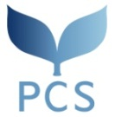
Master’s Program: Peace and Conflict Studies (PCS) Course

2024 Research Proposal

- Make sure to read the directions on page 17 of the Admission Information.
- Make sure to write your name and nationality at the beginning of each page.
- Clearly state the title of your research and stay within 5 pages (maximum 1,500 words) excluding a bibliography.
-------------------------------------------------------------------------------------------------------------------------------------------------

[Title]

