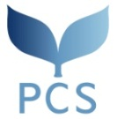
Master’s Program: Peace and Conflict Studies (PCS) Course

2022 Personal Statement

- Make sure to read the directions on page 17 of the Admission Information.
- Make sure to write your name and nationality at the beginning of each page.
- Stay within 3 pages (maximum 1,000 words).
-------------------------------------------------------------------------------------------------------------------------------------------------

