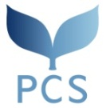
[October 2019 Admission] Doctoral Program in Global Studies
Peace and Conflict Studies (PCS)
Personal Statement

- Make sure to read the directions on page 6 of the Admission Information.
- Make sure to write your name and nationality at the beginning of each page.
- Stay within 3 pages (maximum 1,000 words).
- Submit 4 copies.
-------------------------------------------------------------------------------------------------------------------------------------------------

